**MUHAMMAD NOR HELMI B. MOHAMD SALEH**  
**Graduate in Mechanical Engineering Technology**

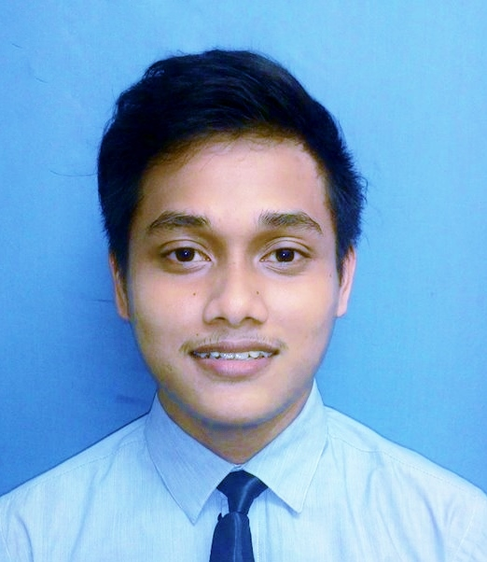

**(Automotive Technology)**

Jalan Anggerik, Kampung Bukit Kuching,

45800 Jeram, Selangor, Malaysia.

Nationality : Malaysia Age : 23 years old

Contact no. : +60133664776 Email : [helmisaleh92@yahoo.com](mailto:helmisaleh92@yahoo.com)

**OBJECTIVE**

A qualified individual with bachelor’s degree in Mechanical Engineering Technology (Automotive Technology) is currently seeking for a job in a reputable company to develop the skills and competencies he has and also for the betterment of the company.

**EDUCATION**

|  |  |
| --- | --- |
| **2011-2015** | ***Bachelor’s Degree in Mechanical Engineering Technology (Automotive Technology) With Honours***  Universiti Teknikal Malaysia Melaka (UTeM)  **Related Coursework:**  Engine Technology, Automotive Electric & Electronic System, Vehicle Brake System, Automotive HVAC, Vehicle Engine & Transmission system, Automotive Ergonomic, Vehicle Suspension System, and Vehicle Transmission System.  **CGPA: 3.32/4.00** |
| **2010-2011** | ***Matriculation Program (Physical Science)***  Malacca Matriculation Collage |
| **2009** | ***Sijil Pelajaran Malaysia (SPM)***  Sekolah Menengah Sains Kuala Selangor  Major in pure science  SPM 8A1B with Bahasa Malaysia (A+) and English (A-) |

**EXPERIENCE**

|  |  |
| --- | --- |
| **February 2015- August 2015**  **(6 months)**  **November 2015-**  **Present** | ***Engineering Trainee***  ***FMC Technologies (Wellhead Equipment)(Surface Assembly Department)***   * Assemble and disassemble Surface Oil & Gas Equipment (Casing Head, Tubing Head, Christmas Tree and etc.) * Assist disposition report for Material Modification Refurbishment (MMR) product. * Involve in internal and customer Factory Acceptance Test (FAT) * Modified and repairing product such as flange, safety for stand, packoff running tool according to Data Base Information (DBI) * Purchasing torque tool equipment, dealing and discussing with vendor about equipment specification in order to make an improvement to the current equipment * Planned and control manpower to improve the work efficiency. * Make a case study for automatic welding which is using Weltron Machine.   ***MRB Coordinator***  ***FMC Technologies(Wellhead Equipment)(QA/QC Subsea Department)***   * Works as a MRB (Material Review Board) coordinator for activities related to subsea product. * Works with Quality, Manufacturing, and Design Engineering groups to obtain disposition of subsea product. * Maintains inventory control of certification (weight certificate, lifting report, pressure test and flushing report and material certificate) * Update and maintain rejection report database and status of rejected material. * Prepare Mechanical Completion Dossier (MCD) documents for completeness and accuracy. Ensure that documents are properly submitted for scanning into network folders. May perform scanning of documents. * Process and move parts per disposition instructions. * Work with Production, Stockroom, and Finance department personnel to maintain accurate data transactions within the SAP system. * May assist manufacturing engineering with documentation of rework. * May perform basic visual inspection and measurement of product. * Perform other job related duties as assigned. |
| **June 2010- September 2010** | ***Promoter at JUSCO***  ***Jusco Bandaraya Melaka***   * Promote product that has been assigned * Record customer purchasing / store sales |

**POSITIVE CRITERIA**

* Enthusiastic, knowledge-hungry learner, eager to meet challenges and quickly assimilate new concepts, exceptional listener and communicator who effectively conveys information verbally and in writing.
* Highly analytical thinking with demonstrated talent for identifying, scrutinizing, improving, and streamlining complex work processes, resourceful team player who excels at building trusting relationships with customers and colleagues.

**SKILLS**

* Written and Verbal Communication in English (good)
* Interpersonal Communication (excellent)
* Proficiency in MS Office (Word, Excel, PowerPoint, Access) (excellent)
* AutoCAD and CATIA (Design, Assemble and Analysis Product) (moderate)
* Arc and MIG welding (moderate)
* Auto Welding (Weltron Machine) (Beginner)
* QC tool (Basic)
* Basic knowledge in Non-Destructive Test (NDT)
* Hydrostatic and Gas Test for Oil & Gas Equipment
* SAP system

**RESEARCH**

***Optimization of Hood Opening for Better Engine Cooling***

* Method to find the way to assist cooling system in order to reduce high temperature inside the engine compartment during hot ambient.
* Type of system that used to reduce temperature at the engine compartment is by made an opening on the hood of car which uses a vent as a component.
* This project is developed to allow air flow directly enters the engine compartment and permit hot air exit to the surrounding.
* This research are conducted by analyses the temperature at the engine compartment before made hood opening and after hood opening is install.

**ACTIVITIES**

* Participate in Formula Student Racing Car in Engineering Safety Challenge (2014)
* Place: UTeM
* Duration: 6 weeks
* Position: Driver in braking system challenge
* Working Scope: Develop and Fabricate Chassis
* Participate in (Sukan Antara Fakulti) Represents Futsal Team (2013)
* Role: To lead defensive line from opponent attack
* Participate in FMC Technologies Futsal Tournament Represent Surface Department (2015)
* Role: To lead attacking line

**ADDITIONAL INFO**

**Academic Award**

* Dean’s List for Semester 1, Semester 6 and Semester 7

**Courses**

* Industrial Certificate Program (ICP) (Robust Design in Industry)
* Graduate Interpersonal Skills Training (GIST)
* Industrial Certificate Program (ICP) (Automotive Air Conditioning Compressor Performance Test in Industry)
* Industrial Certificate Program (ICP) (Industrial Development Product)
* Occupational Safety and Health (OSHA)
* Overhead Crane (FMC Technologies)
* START course (FMC Technologies)
* Tester level 1 (Hydrostatic testing with supervision) (FMC Technologies)

**Others**

* Willing to Travel: Yes
* Possess own Transport: Yes
* Driving License: D, B2
* Expected Salary : RM2200- RM2500 (Negotiable)

**REFERENCES**

Nor Hamizah Binti Miswan

Academic Advisor

Universiti Teknikal Malaysia Melaka (UTeM)

Tel: 06-23466936

E-mail: [norhamizah@utem.edu.my](mailto:norhamizah@utem.edu.my)

Ahmad Rafie Bin Mohamad Tahir

SF Assembly Engineer

FMC Technologies (Wellhead Equipment)

Tel:07-2672119

Email: AhmadRafie.MohamadTahir@fmcti.com.my